Think About What You Think
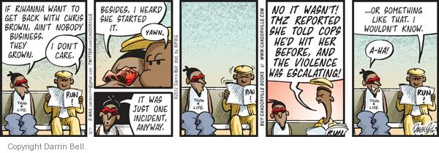
“Never forget that walking away from something unhealthy is brave even if you stumble a little on your way out the door.” ~ Unknown

Food for Thought...
Stress and isolation, from the pandemic for example, can create combustible tensions. Additionally, a lack of privacy subjects many victims to intense monitoring and closer surveillance by their abuser.
Think about this statement as you watch the video and complete the rest of the assignment. Make sure you follow the assignment instructions.

The Prompt
The cycle of abuse was first theorized by Dr. Lenore Walker, in 1979, after she interviewed 1,500 women who were survivors of domestic violence. Abuse comes in many forms, and, sadly, domestic violence can happen to anyone; no one is immune. Escaping an abusive relationship is not easy. It is even more difficult when the victim is being isolated from family and friends, psychologically beaten down, physically threatened, and financially controlled by an a batterer. Recognizing the signs and symptoms of domestic violence begins by observing the behavior of both the abuser and the person being abused. The abuser may appear overly controlling or coercive. The abuser may attempt to speak for the victim. This type of behavior occurs most often in the context of a visit to the doctor where the abuser refuses to let the victim out of his sight and attempts to answer all questions for the victim. Silent crying and poor eye contact may be outward signs, but if the abused person appears quiet and passive, you may be witnessing depression and emotional abuse, another form of domestic violence, actually taking place. Substance abuse is also more common in the person enduring domestic violence than in the general adult population. The abuse of alcohol, prescription drugs, and illicit drugs may happen as a result of the violent relationship rather than being the cause of the violence.

The Assignment Instructions
- Watch "Therapist talks about domestic violence" video here.
- Referencing the video, your textbook, and other resources, discuss the battering cycle, the battered woman, and the batterer.
- Why do people stay in abusive relationships?
- Reference your sources in your response.
Note:
- Word count is 300-500 words
- You must submit a post BEFORE you can see your classmates posts.
- Ideally, your response to your classmates should consist of a complete thought that contributes to the dialogue and furthers the discussion.
- There are no right or wrong responses, so share your knowledge, insights and thoughts freely.
- but please be respectful to one another as you explore and discuss your ideas.
- See the discussion rubric (in rubric link on the navigation bar) for grading criteria.
- Discussion is due on Sunday April 18, 2021 at 11:59pm.

